NOTICE OF RE-Exhibition – DRAFT EL CABALLO BLANCO AND GLEDSWOOD VOLUNTARY PLANNING AGREEMENT (vpa)

Proposal

Council is re-exhibiting the Draft El Caballo Blanco and Gledswood Voluntary Planning Agreement (VPA). The draft VPA applies to a portion of land within Gledswood Hills owned by Sekisui House (as shown in green in Figure 1 below).

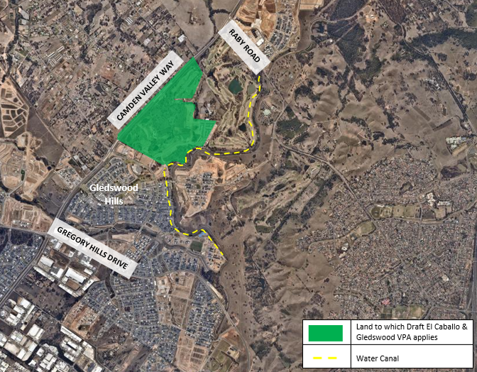
Figure 1: Location Map

The Draft VPA

The draft VPA is associated with the development of the land for urban purposes, involving subdivision to accommodate up to 400 dwellings, associated non-residential development and infrastructure.

The draft VPA seeks to dedicate 9.08 hectares of riparian and bushland to Council.

Works in kind will also be provided for cycleway linkages, landscaping, vegetation establishment and vegetation management for 5 years, meaning Council will receive embellished and revegetated land. A two-lane vehicular crossing will also be provided at Rileys Creek.

The draft VPA also contains an option of dedicating a further 3.65 hectares of riparian and bushland, subject to the consent of the registered proprietor of that land.

The draft VPA also proposes 1.15 hectares of passive open space, which will be provided as Community title with the option to dedicate this land to Council.

Exhibition

The draft VPA will be exhibited from 27 May 2019 until 24 June 2019.

Exhibition Material

The material for exhibition includes the following:

- Cover Page
- Notice of Exhibition
- Privacy Notice & Disclosure of Political Donations
- Draft El Caballo Blanco and Gledswood Voluntary Planning Agreement (VPA)

Exhibition Locations

- Hard Copy – Council Administration Building – 70 Central Avenue, Oran Park
- Hard Copy – Oran Park Library – 72 Central Avenue, Oran Park
- Hard Copy - Camden Library - 40 John Street, Camden
- Hard Copy - Narellan Library - Cnr Queen and Elyard Street, Narellan
- Electronic Copy - Camden Council Website - www.camden.nsw.gov.au

Submissions

Submissions regarding the draft VPA will be received by Council until close of business on Monday 24 June 2019. All submissions should be marked attention to Jacob Hatch and can be emailed to mail@camden.nsw.gov.au or addressed to:

The General Manager
Camden Council
P O Box 183
Camden NSW 2570

For any further enquiries, please contact Council’s Contributions Planner, Jacob Hatch on (02) 4654 7777.

